CAPSTONE PROJECT REPORT
Design and Implementation of a Data-Driven E-Commerce Test Automation Framework Using Robot Framework, SeleniumLibrary, RIDE IDE and Jenkins CI/CD
Project: EcommerceRobotFramework
Application under test: https://automationexercise.com/
UNIVERSITY OF ENGINEERING AND MANAGEMENT (UEM), KOLKATA
Bachelor of Technology in Computer Science and Engineering

Submitted by
Sayantana Halder
Enrollment No: 12023002001338

Abstract
This report describes the design and implementation of a modular, data-driven test automation framework for the Automation Exercise e-commerce website (https://automationexercise.com/), built with Robot Framework, SeleniumLibrary and Selenium WebDriver. The framework applies the Page Object Model through reusable resource files, reads product search terms (Dress, Top and Saree) from a CSV file, and executes them in a single test case and a single login session. For every term, it empties the cart, searches for the product, adds the first result to the cart, opens the cart and verifies that the correct product name is present.
The same test was executed successfully in three environments: from the command line, from the RIDE IDE, and from a Jenkins Pipeline job on Windows 11 with credentials supplied through the Jenkins credential store. Each execution ended with one test passed and none failed and produced Robot Framework output.xml, log.html and report.html files. The report documents the architecture, source code, the Jenkins installation and configuration, and the problems encountered, in particular Google advertisement iframes that intercepted clicks on Add to Cart and View Cart, which were resolved with a JavaScript fallback click. The verified workflow covers login, product search, adding to the cart, cart validation and logout; it does not include checkout or payment.
Keywords: Robot Framework, SeleniumLibrary, data-driven testing, Page Object Model, RIDE, Jenkins, CI/CD, test automation.
Table of Contents
1. Module Name and Experiment Title 1
2. Problem Statement 1
3. Objectives 1
4. Tools, Software and Concepts Used 1
4.1 Tools Used 1
4.2 Concepts Used 1
5. Source Code and Implementation Steps 1
5.1 Project Architecture 1
5.2 Environment Setup 1
5.3 Shared Resources 1
5.4 Page Objects 1
5.5 Test Data and the Data-Driven Test 1
5.6 Method 1: Command-Line Execution 1
5.7 Method 2: RIDE IDE 1
5.8 Method 3: Jenkins CI/CD 1
5.9 Problems Faced and Solutions 1
6. Output With Clearly Labelled Screenshots 1
6.1 Command-Line Output 1
6.2 RIDE Output 1
6.3 Jenkins Output 1
7. Results, Observations and Conclusion 1
7.1 Results 1
7.2 Observations 1
7.3 Lessons Learned 1
7.4 Limitations and Future Improvements 1
7.5 Conclusion 1
References 1

1. Module Name and Experiment Title
Module name | Software Testing and Test Automation
Experiment title | Design and Implementation of a Data-Driven E-Commerce Test Automation Framework Using Robot Framework, SeleniumLibrary, RIDE IDE and Jenkins CI/CD
Student | Sayantana Halder
Programme | B.Tech in Computer Science and Engineering
Institution | University of Engineering and Management (UEM), Kolkata

2. Problem Statement
Testing an e-commerce website by hand is slow and repetitive. The same steps (login, search a product, add it to the cart, check the cart) have to be repeated after every change, and each product needs a different search term. Manual checking is also not always consistent: a tester may forget to remove old items from the cart, or may compare product names loosely. When the website changes, badly organised test scripts are hard to maintain, and manual results are not saved in a proper report.
Real websites also show advertisements. In this project a Google advertisement iframe sometimes covered the Add to Cart and View Cart links, so a normal Selenium click failed even though the button was visible.
To solve these problems I used:
- Data-driven testing, so the search terms come from a CSV file and new products can be added without changing the test.
- Reusable page objects and resource files, so each locator is written only once.
- RIDE IDE, to open, inspect and run the same test graphically.
- Jenkins CI/CD, to run the test from a pipeline, keep the credentials safe and save the reports automatically.

3. Objectives
- Automate an e-commerce journey: login, search, add to cart, verify the cart, logout.
- Create reusable page objects and resource files.
- Read the product search terms from a CSV file.
- Run several product searches (Dress, Top, Saree) in one login session.
- Verify that the correct product is added to the cart.
- Run the test from the command line and from RIDE IDE.
- Integrate the framework with Jenkins.
- Generate Robot Framework HTML and XML reports.
- Handle advertisement-related click interception with a JavaScript fallback click.

4. Tools, Software and Concepts Used

4.1 Tools Used
Table 1: Tools and software used in the project
Tool | Version / note | Purpose in this project
Robot Framework | 7.5 | Runs the tests and creates output.xml, log.html, report.html
SeleniumLibrary | 6.9.0 | Gives Robot keywords such as Open Browser, Click Element, Execute Javascript
Selenium WebDriver | selenium 4.49.0 | Controls the browser
Python | 3.14.7 | Runs Robot Framework; provides venv and pip
Google Chrome | — | Browser used for the tests. No driver path is set in the project; Selenium handled the driver
RIDE IDE | 2.2.4 | Graphical editor and runner for Robot tests
Jenkins | 2.583 | CI/CD server that ran the pipeline
Java JDK | 25.0.2 | Needed to run Jenkins
Windows 11, PowerShell |  | Operating system and shell used for all work
VS Code |  | Used to write and edit the code
CSV file | search_products.csv | Stores the test data
Robocopy | Windows tool | Copied the project into the Jenkins workspace

A .gitignore file, a Firefox option in the run scripts, and the Robot Framework Jenkins plugin (RobotPublisher) appear in the project files, but I did not use or verify them in the final work, so they are not counted as tools used.

4.2 Concepts Used
- Keyword-driven testing: tests are written with readable keywords such as Search For Product.
- Data-driven testing: the same test runs with different data from a CSV file.
- Page Object Model: each page has its own resource file with its locators and keywords.
- Resource files and locators: shared settings are in variables.resource; elements are found using id, css and xpath locators.
- Explicit waits: keywords like Wait Until Element Is Visible wait only as long as needed (up to 15 seconds).
- Exception handling and JavaScript fallback: Run Keyword And Return Status lets the test try a normal click first, and if it fails, click with JavaScript.
- Virtual environment: .venv keeps the project packages separate from the system Python.
- CI/CD, Jenkins credentials and artifacts: a pipeline runs the steps automatically; secrets are stored in Jenkins and referred to by ID; reports are archived with the build.

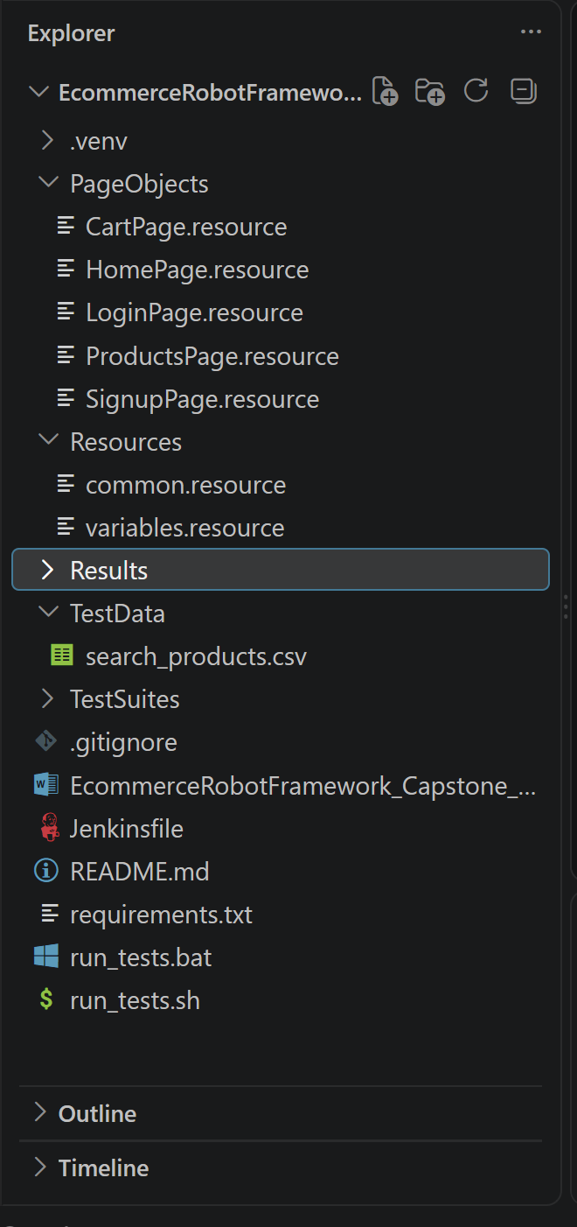

5. Source Code and Implementation Steps

5.1 Project Architecture
The test suite calls keywords from the page objects and resource files. These use SeleniumLibrary, which controls Chrome through Selenium. Test data is kept in a CSV file and the reports go to the Results folder (Figure 1).
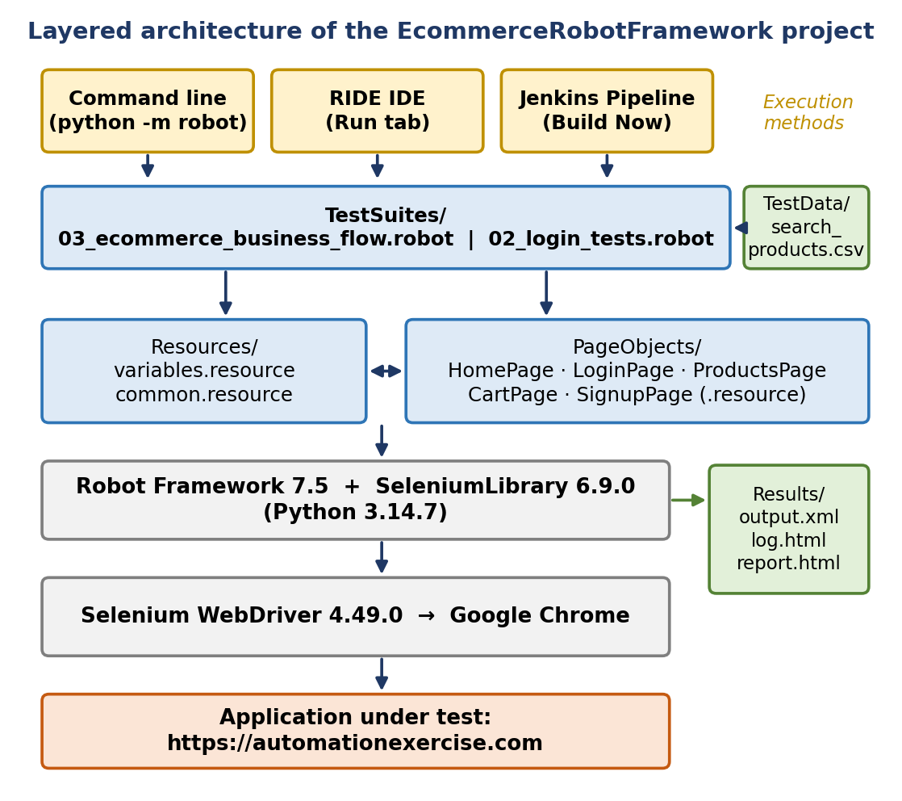
Figure 1: Architecture of the EcommerceRobotFramework project
EcommerceRobotFramework/
+-- PageObjects/ HomePage, LoginPage, ProductsPage, CartPage, SignupPage (.resource)
+-- Resources/ variables.resource, common.resource
+-- TestData/ search_products.csv
+-- TestSuites/ 01_registration_tests.robot.disabled
| 02_login_tests.robot
| 03_ecommerce_business_flow.robot
+-- Results/ output.xml, log.html, report.html
+-- requirements.txt, Jenkinsfile, README.md, run_tests.bat, run_tests.sh
I checked this structure against the uploaded project. The only difference is that the registration suite is saved as 01_registration_tests.robot.disabled, so Robot Framework does not run it. It was not needed for the assigned business flow.
Keeping page objects, shared resources, test data and test suites in separate places makes the project easier to maintain. If a locator changes, I edit one page object file. If I want another product, I add one line to the CSV. Keywords like Open Application and Login With Existing Account are reused by more than one suite.
Figure 2: Project folder structure in VS Code
What this shows: The folders and files described above.

5.2 Environment Setup
requirements.txt contains:
robotframework>=6.1.1
robotframework-seleniumlibrary>=6.2.0
The virtual environment was created and the packages installed like this:
py -m venv .venv
.\.venv\Scripts\Activate.ps1
pip install -r requirements.txt

5.3 Shared Resources
variables.resource stores the browser (chrome), the URL, the timeout (15 s) and the test account values. The account values use the syntax %{VAR=default}, which reads an operating-system environment variable if it exists. Jenkins uses this to pass the real account details, so the email and password are not written in the code.
${TEST_USER_NAME} %{RF_TEST_NAME=Robot Tester}
${TEST_USER_EMAIL} %{RF_TEST_EMAIL=<placeholder default>}
${TEST_USER_PASSWORD} %{RF_TEST_PASSWORD=<placeholder default>}
common.resource has the browser life-cycle keywords. Open Application opens Chrome, maximises it and opens the home page. Finish Test is the test teardown: it takes an embedded screenshot only if the test failed and then closes the browser. Login With Existing Account logs in and checks the “Logged in as” text.

5.4 Page Objects
Each page object holds the locators and keywords of one page: HomePage (open site, check login, logout), LoginPage (login form), ProductsPage (search, add to cart, cart modal), CartPage (empty cart, verify product) and SignupPage (account form, used by the disabled registration suite). The most important keywords are explained below.
Add Product To Cart By Index first tries a normal click. If an advertisement blocks it (ElementClickInterceptedException), the click is done with JavaScript:
${clicked}= Run Keyword And Return Status Click Element ${add_link}

IF not ${clicked}
Log Normal Add to Cart click was intercepted; trying JavaScript click. WARN
${button}= Get WebElement ${add_link}
Execute Javascript arguments[0].click(); ARGUMENTS ${button}
END
Run Keyword And Return Status returns False instead of failing the test, Get WebElement gets the element and Execute Javascript clicks it directly, so the advertisement cannot block it.
Go To Cart From Modal uses the same idea for the View Cart link. It is in ProductsPage.resource because the link is in the modal opened from the products page. This keyword was fixed after a Jenkins build failed (Section 5.8).
Go To Cart From Modal
[Documentation] Open the cart, using JavaScript if an advertisement intercepts the click.
Wait Until Element Is Visible ${MODAL_VIEW_CART_LINK} timeout=${TIMEOUT}

${clicked}= Run Keyword And Return Status
... Click Element ${MODAL_VIEW_CART_LINK}

IF not ${clicked}
Log Normal View Cart click was intercepted; trying JavaScript click. WARN
${cart_link}= Get WebElement ${MODAL_VIEW_CART_LINK}
Execute Javascript arguments[0].click(); ARGUMENTS ${cart_link}
END

Wait Until Location Contains /view_cart timeout=${TIMEOUT}
Remove All Products From Cart empties the cart before each product so that old items cannot give a false pass. Cart Should Contain Product reads the product names in the cart, removes extra spaces from both the expected and actual names using Replace String Using Regexp and Strip String, and then checks that the expected name is in the list. This was needed because the website sometimes returns names with extra spaces; for example the local log shows “Sleeveless Dress” with two spaces, which would not match otherwise.

5.5 Test Data and the Data-Driven Test
search_term,min_expected_results
Dress,1
Top,1
Saree,1
The keyword Read Search Rows From File reads this file, skips the header, splits every line by comma and returns the terms and minimum result counts. Adding another product only needs another CSV line; the test case does not change. The main test is in TestSuites/03_ecommerce_business_flow.robot:
Complete Purchase Journey For Every Product In The Data File
[Documentation] Test Dress, Top and Saree in one login session.
[Tags] e2e data-driven regression

@{rows}= Read Search Rows From File ${SEARCH_DATA_FILE}
Login With Existing Account

FOR ${term} ${minimum} IN @{rows}
Log To Console Testing search term: ${term}
Remove All Products From Cart
Open Products Page
Search For Product ${term}
Search Results Should Meet Minimum ${minimum}
${product_name}= Get Product Name By Index 1
Add Product To Cart By Index 1
Go To Cart From Modal
Cart Should Contain Product ${product_name}
Log To Console Successfully verified: ${product_name}
END

Logout From Application
The workflow is shown in Figure 3. The browser opens in the test setup, the CSV is read, the login is done once, and the loop handles Dress, Top and Saree. After the loop the test logs out once and the teardown closes the browser and Robot Framework writes the reports.
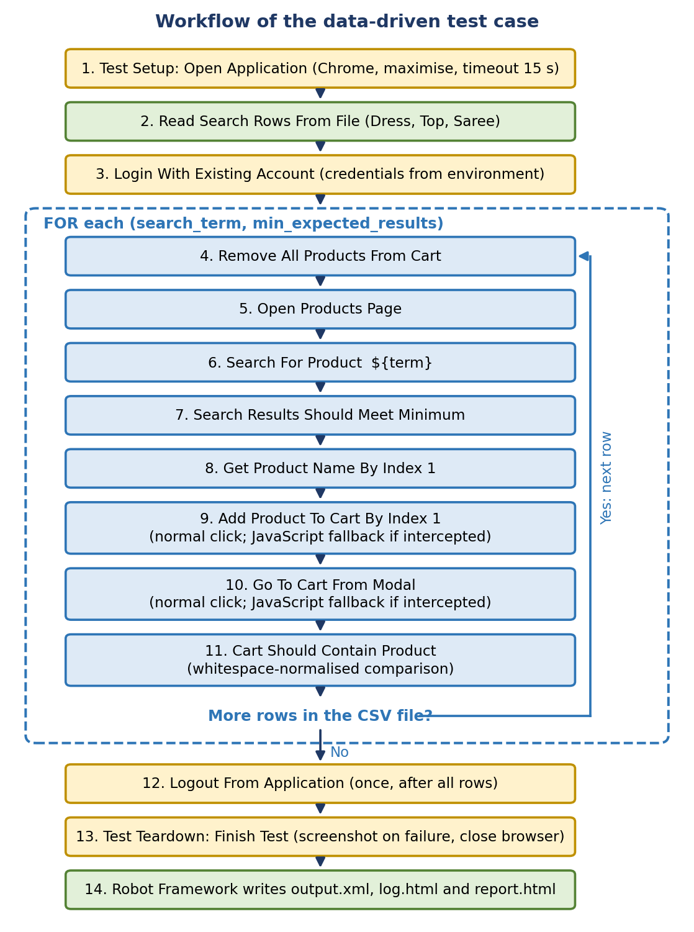
Figure 3: Workflow of the data-driven test
One test, one login
All three CSV rows run inside one test case and one login session. So Robot Framework shows 1 test, 1 passed, 0 failed, not three separate tests. The suite also has another test, “Complete Purchase Journey For One Product”, which was not run because the command used the --test option.

Table 2: Products verified from the CSV data
CSV search term | Product verified in the cart
Dress | Sleeveless Dress
Top | Blue Top
Saree | Cotton Silk Hand Block Print Saree

5.6 Method 1: Command-Line Execution
The project folder was C:\Users\sayan\OneDrive\Desktop\Selenium_Assignment\EcommerceRobotFramework. From PowerShell, inside the virtual environment, the successful command was:
python -m robot --outputdir Results --test "Complete Purchase Journey For Every Product In The Data File" TestSuites/03_ecommerce_business_flow.robot
- python -m robot runs Robot Framework with the Python of the virtual environment.
- --outputdir Results saves the reports in the Results folder.
- --test "..." runs only the data-driven test, so the summary shows one test.
- The last argument is the suite file.
Robot Framework creates three files: output.xml (full machine-readable result of the run), log.html (detailed keyword-by-keyword log used for debugging) and report.html (summary with pass/fail count). The result was 1 test, 1 passed, 0 failed, with Dress, Top and Saree verified. The screenshots are in Section 6.1.
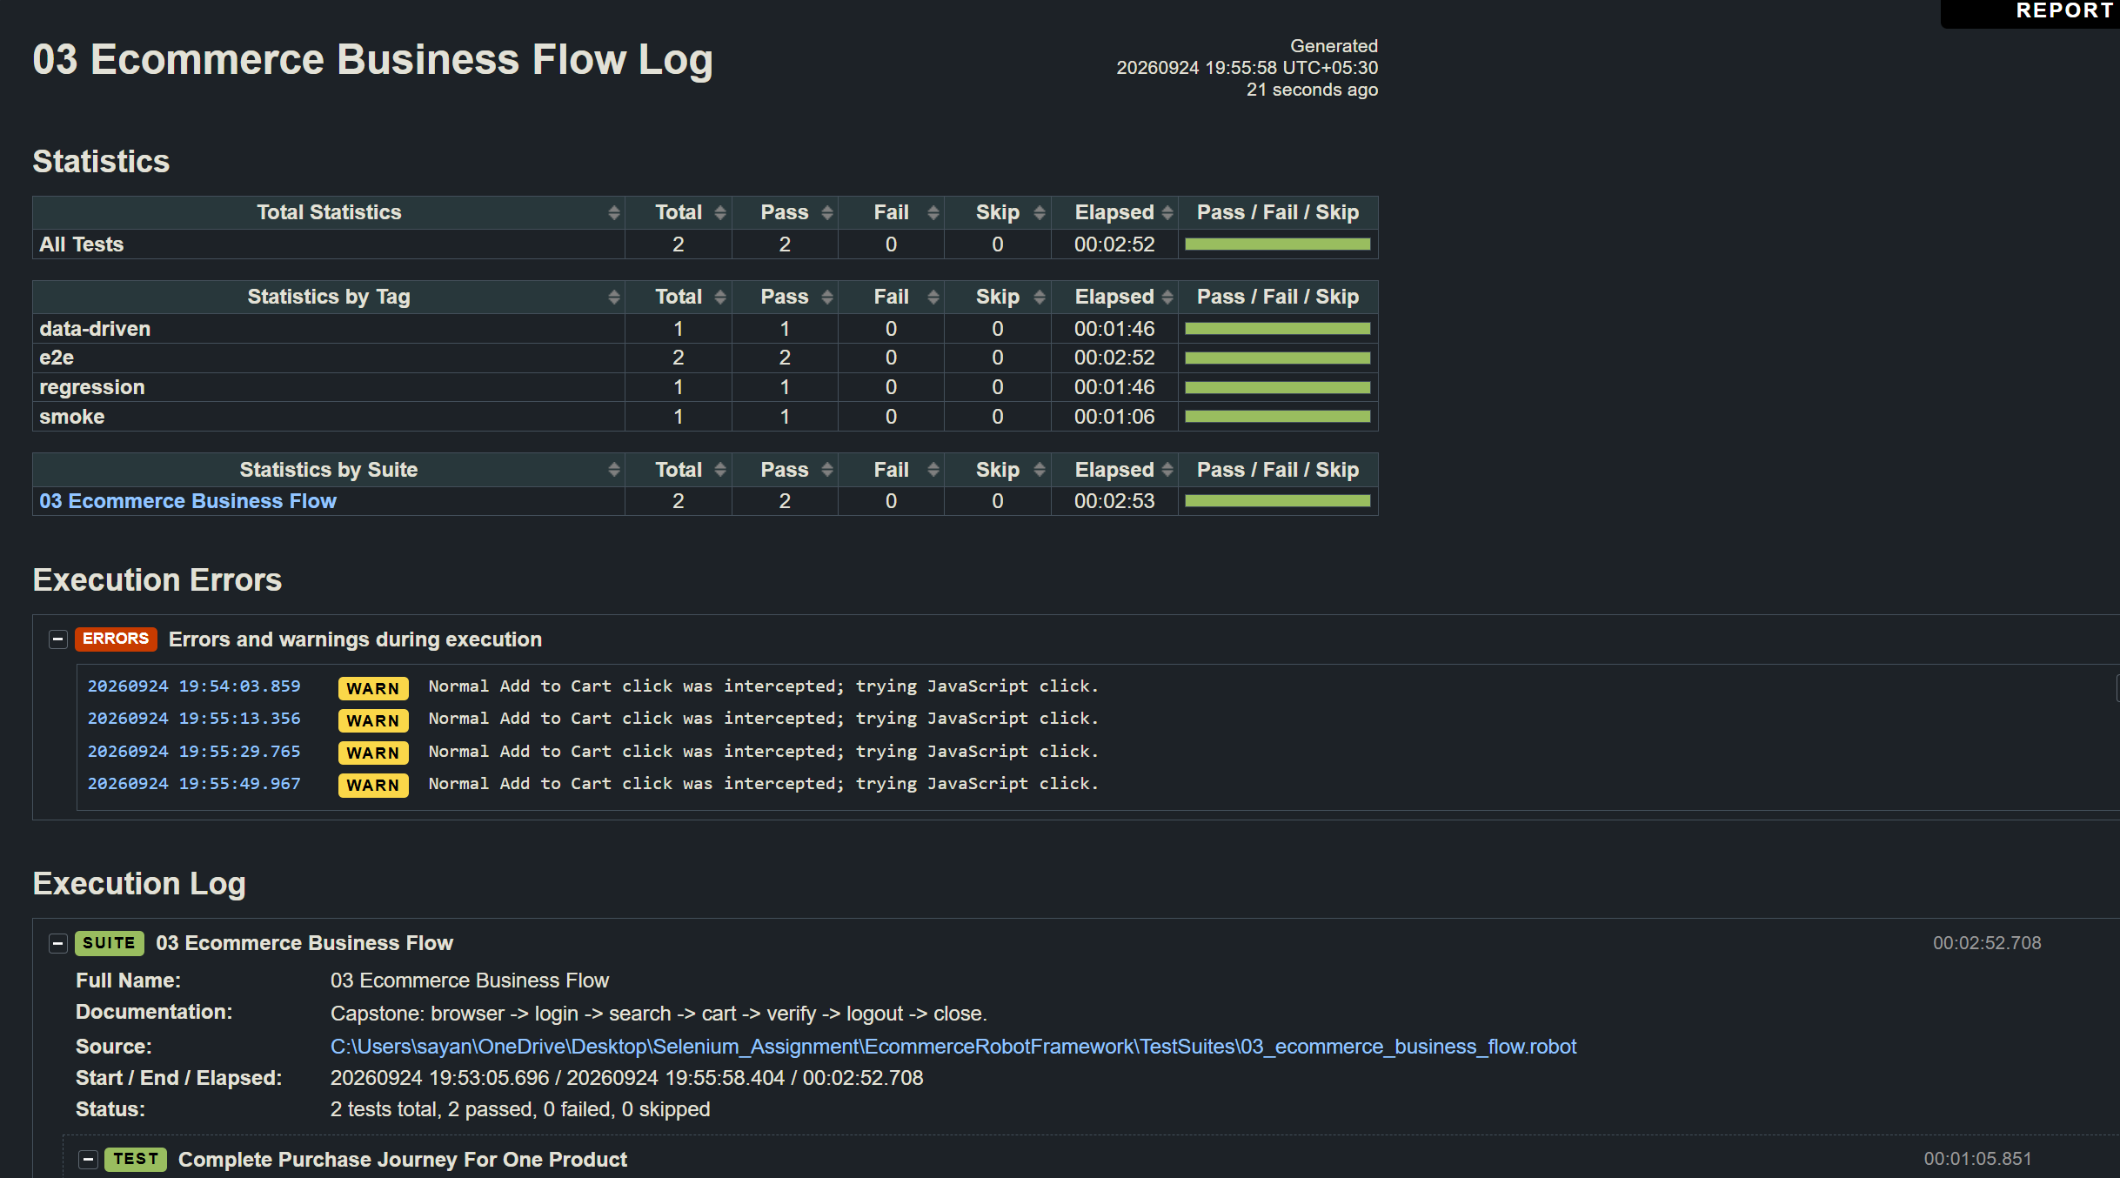

5.7 Method 2: RIDE IDE
RIDE is a graphical editor for Robot Framework. It shows the suite, its resources and keywords in a tree, and has a Run tab to start tests and see the progress. It was installed in the project’s virtual environment and launched with the main suite:
python -m pip install robotframework-ride
& ".\.venv\Scripts\ride.exe" ".\TestSuites\03_ecommerce_business_flow.robot"
The steps were:
- Used the project’s virtual environment and launched RIDE with the command above.
- Opened 03_ecommerce_business_flow.robot and checked the imported resources, the test case and the keywords.
- Selected the data-driven test case on the Run tab and set the execution options as needed.
- Started the run and watched the browser and the execution log.
- Checked the result and opened the generated report and log.
The account values are read from environment variables, so they must be available to the process that starts RIDE. The test code was not changed for RIDE; only the way of running it was different.
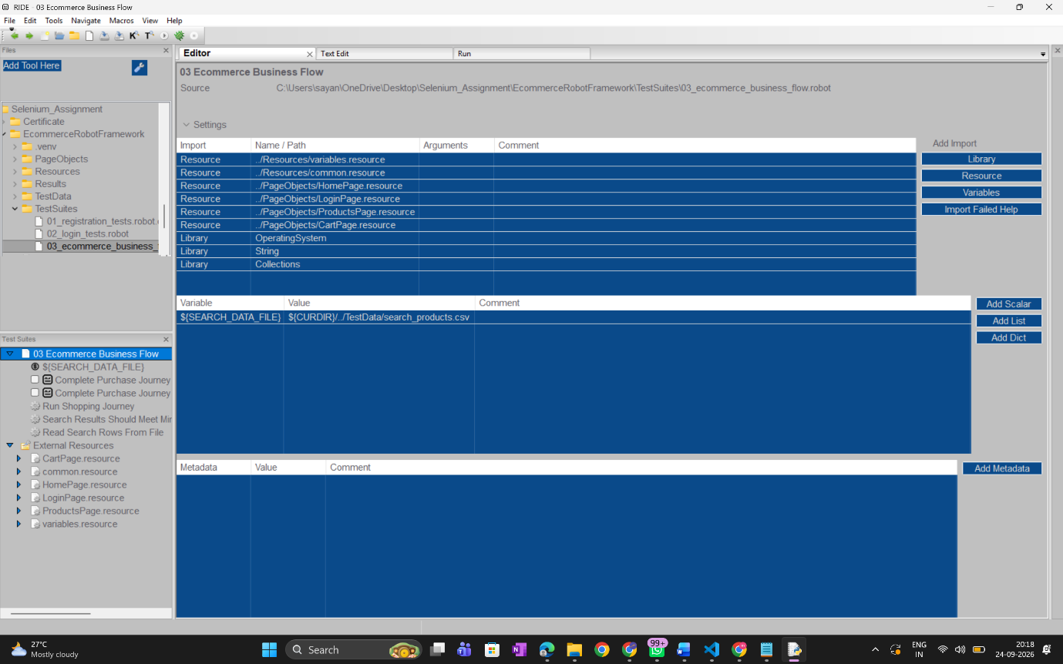

Figure 4: RIDE with the test suite loaded

5.8 Method 3: Jenkins CI/CD
Jenkins was set up manually on Windows 11.
Installation. I installed Jenkins 2.583 with the Windows installer, using Java at C:\Program Files\Java\jdk-25.0.2. At first I tried to run the service with my local Windows account, but it gave error 0x8007052e. Then I used the LocalSystem account and the installation worked. Jenkins opened at http://localhost:8080; I unlocked it with the initial administrator password from the Jenkins configuration folder and installed the suggested plugins. Some plugins failed the first time, so I used the retry and continue options of the setup wizard. I did not check every optional plugin.
Job and environment check. I created a Pipeline job named EcommerceRobotFramework. Before running the browser test, a first pipeline checked the environment with whoami, java -version, python --version and where python.
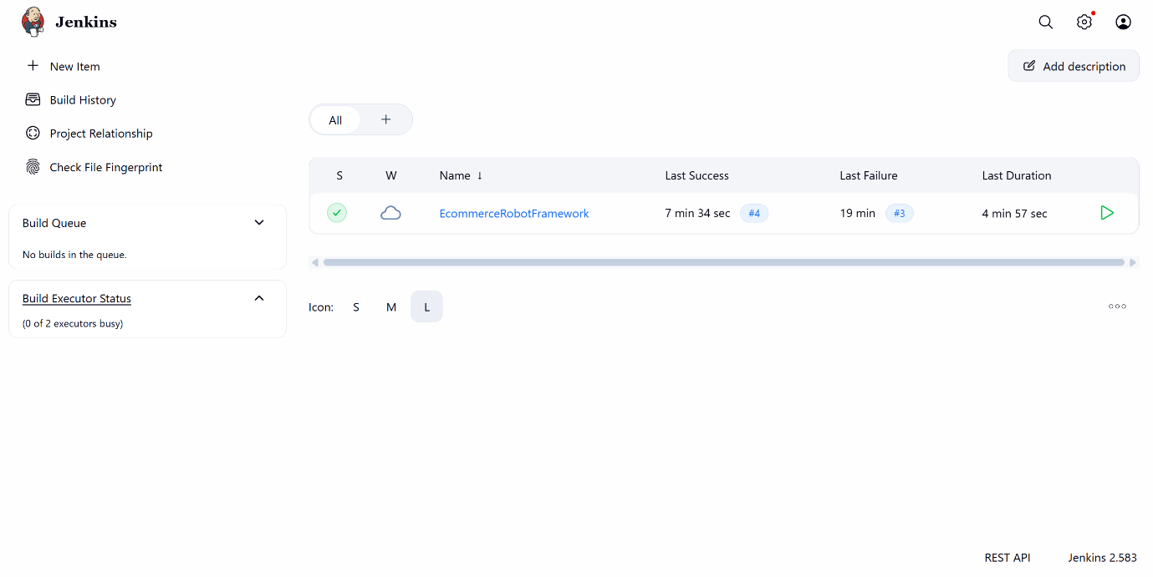

What this shows: The Pipeline job created in Jenkins.
Workspace. Jenkins runs the project from its own workspace, not from the VS Code folder:
C:\ProgramData\Jenkins\.jenkins\workspace\EcommerceRobotFramework
I copied the project there using PowerShell and Robocopy and checked the files. The console showed that the CSV in the workspace was exactly the three rows Dress, Top and Saree. Because the workspace is a separate copy, after fixing a file in VS Code I had to copy it into the workspace again. I did not use Git checkout or automatic synchronisation.
Credentials. To avoid writing the account email and password in the code, I stored them in Jenkins with the IDs automationexercise-test-email and automationexercise-test-password. The pipeline gives them to the test as environment variables, and Jenkins hides their values in the console. The real values are not written in this report.
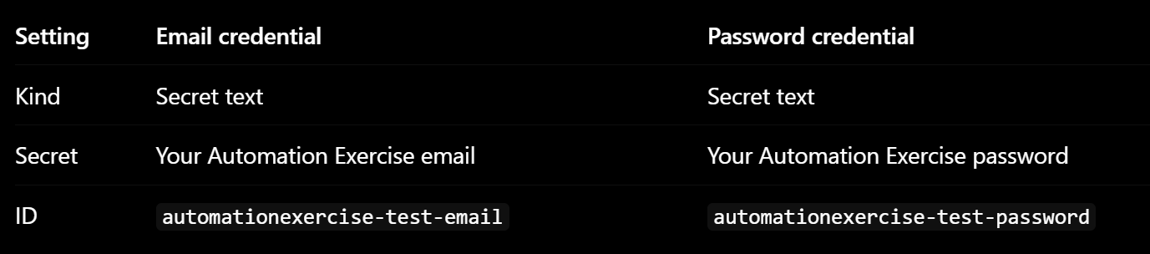
Figure 8: Jenkins credentials for the test account
What this shows: The two credential IDs stored in Jenkins, without secret values.
Final pipeline. The pipeline used in the Jenkins job was:
pipeline {
agent any

options {
timestamps()
timeout(time: 40, unit: 'MINUTES')
}

environment {
RF_TEST_EMAIL = credentials('automationexercise-test-email')
RF_TEST_PASSWORD = credentials('automationexercise-test-password')
RF_TEST_NAME = 'Sayantana Halder'
}

stages {
stage('Verify Project Files') {
steps {
bat 'dir'
bat 'type TestData\\search_products.csv'
}
}

stage('Create Virtual Environment') {
steps {
bat '''
if not exist .venv\\Scripts\\python.exe (
python -m venv .venv
)
.venv\\Scripts\\python.exe --version
'''
}
}

stage('Install Dependencies') {
steps {
bat '''
.venv\\Scripts\\python.exe -m pip install -r requirements.txt
'''
}
}

stage('Execute Robot Framework Tests') {
steps {
bat '''
.venv\\Scripts\\python.exe -m robot --outputdir Results --test "Complete Purchase Journey For Every Product In The Data File" TestSuites/03_ecommerce_business_flow.robot
'''
}
}
}

post {
always {
archiveArtifacts(
artifacts: 'Results/*.html,Results/*.xml,Results/*.png',
allowEmptyArchive: true
)
}
}
}
- agent any: the build can run on any available agent (here, the Jenkins server itself).
- options: timestamps() adds a time to every console line; timeout stops the build after 40 minutes.
- environment: passes the two credentials and the account name to the test.
- Stages: check the project files and CSV, create the virtual environment, install the requirements, then run the same Robot command used on the command line.
- post { always }: archives the reports after every build, even when the test fails, so they can be used for debugging.
The Jenkinsfile inside the project ZIP is a different, repository-style version (it uses a windows agent label, checkout scm and the RobotPublisher plugin), so the pipeline above is the one that was actually used. All builds were started manually with Build Now.
Figure 9: Pipeline script in the Jenkins job
What this shows: The final pipeline as configured in Jenkins.

5.9 Problems Faced and Solutions
Table 3: Problems faced during Jenkins integration
No. | Problem | Cause | Solution
1 | Jenkins service failed with error 0x8007052e | The local Windows account could not be used for the service | Used the LocalSystem account
2 | Some suggested plugins failed to install | Installation failed during setup | Used retry and continue in the setup wizard
3 | Jenkins did not run my latest code | Jenkins uses its own workspace, separate from VS Code | Copied the project and, later, the fixed file into the workspace
4 | Add to Cart click sometimes failed | Google advertisement iframe covered the link | Normal click first, JavaScript click as fallback
5 | Jenkins build failed with ElementClickInterceptedException at View Cart | Advertisement iframe covered the View Cart link and Go To Cart From Modal had no fallback | Added the same fallback, copied the file to the workspace and ran the pipeline again
6 | Possible wrong mismatch in product names | Product names had extra spaces | Normalised spaces before comparing

Problem 5 was the main reason for the unsuccessful Jenkins build. The console showed ElementClickInterceptedException because an advertisement covered the View Cart link. The old keyword only did a normal click. After I changed it to the version shown in Section 5.4 and copied the file into the Jenkins workspace, the next build passed.
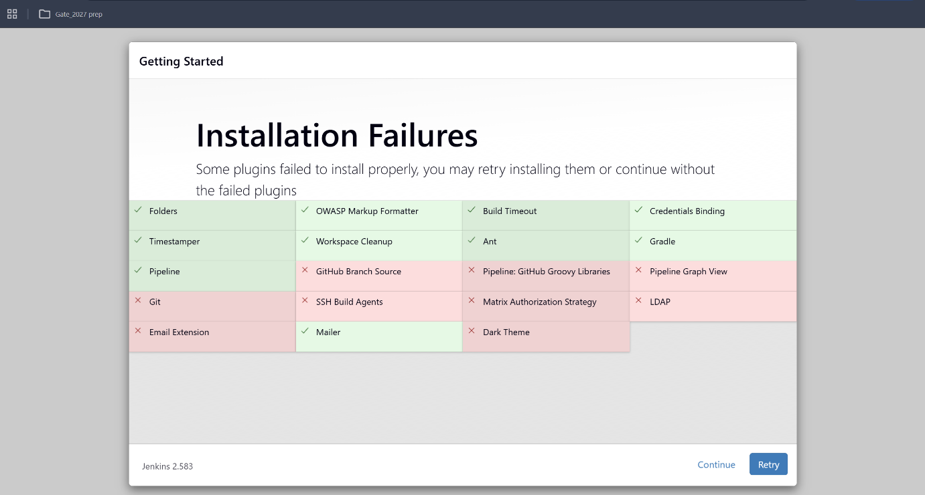

6. Output With Clearly Labelled Screenshots

6.1 Command-Line Output
The command in Section 5.6 verified Dress, Top and Saree and ended with 1 test, 1 passed, 0 failed.
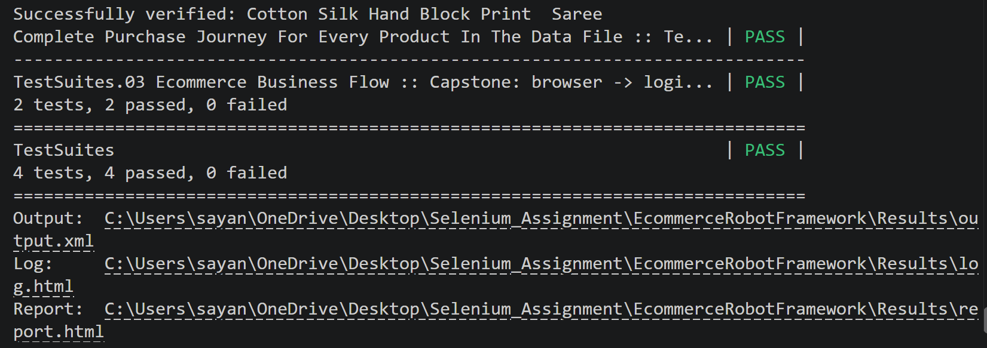
Figure 12: Successful command-line execution
What this shows: The report showing the test status PASS.

6.2 RIDE Output
The same test was run from RIDE. It gave 1 passed, 0 failed, and the elapsed time was approximately 2 minutes 3 seconds.
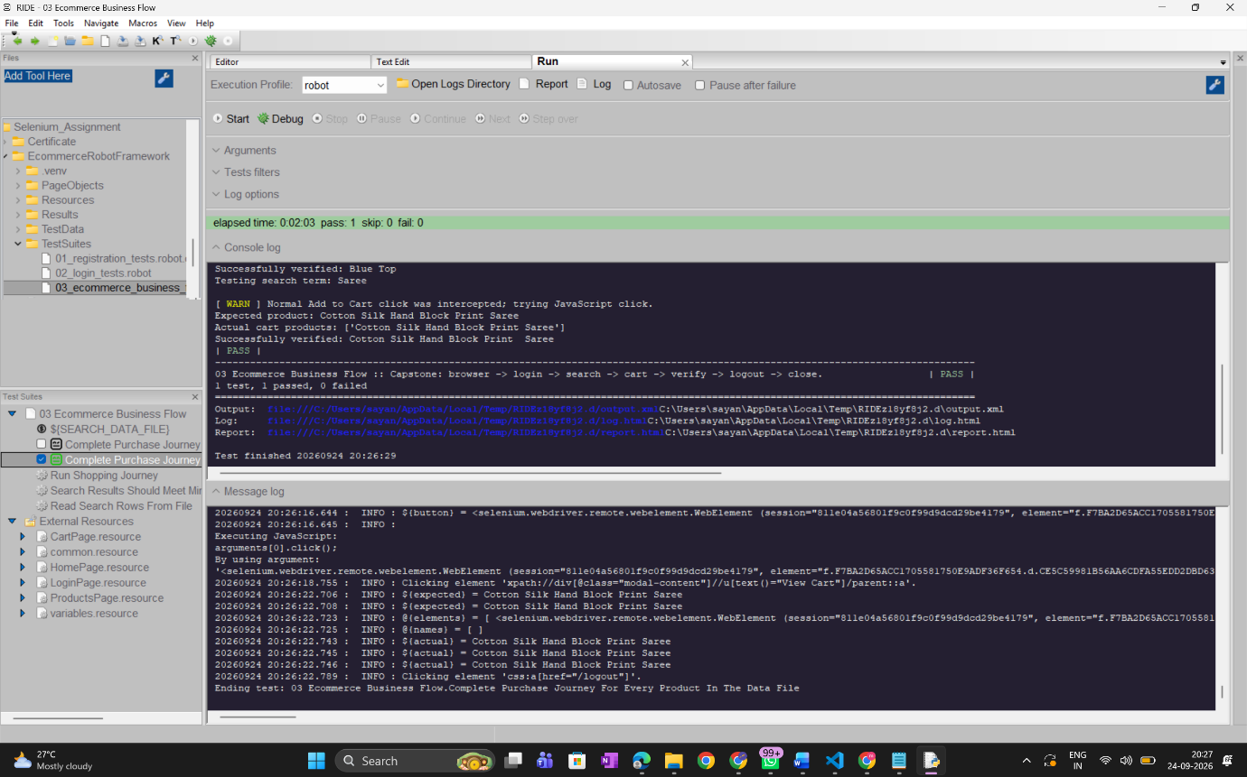
What this shows: One passed, zero failed, elapsed time about 2 minutes 3 seconds.

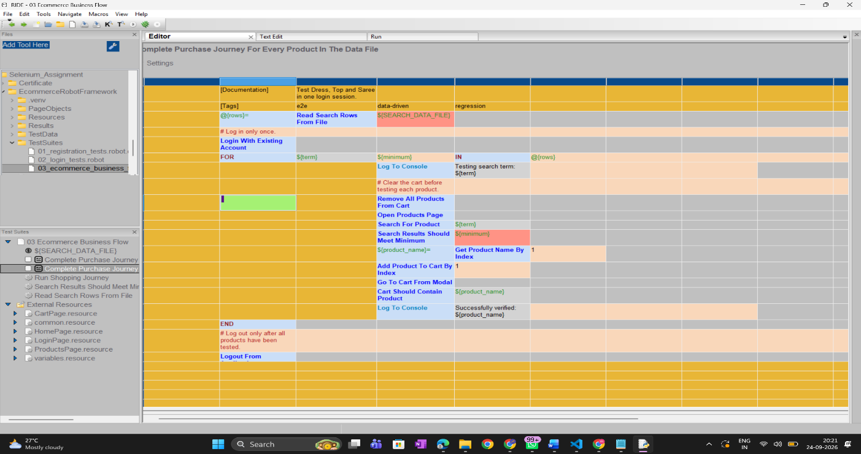

6.3 Jenkins Output
After the View Cart fix was copied into the workspace, I ran the pipeline with Build Now. The Jenkins console showed:
Testing search term: Dress
Expected product: Sleeveless Dress
Actual cart products: ['Sleeveless Dress']
Successfully verified: Sleeveless Dress

Testing search term: Top
Expected product: Blue Top
Actual cart products: ['Blue Top']
Successfully verified: Blue Top

Testing search term: Saree
Expected product: Cotton Silk Hand Block Print Saree
Actual cart products: ['Cotton Silk Hand Block Print Saree']
Successfully verified: Cotton Silk Hand Block Print Saree

1 test, 1 passed, 0 failed
Finished: SUCCESS
The console also showed warnings that the JavaScript fallback was used when advertisements intercepted normal clicks. The build created Results/output.xml, Results/log.html and Results/report.html, which were archived, and took approximately 4 minutes 56 seconds. This proves that the framework runs successfully through Jenkins, from the Jenkins workspace, with credentials from the Jenkins store.
Figure 15: Jenkins console output for the successful build
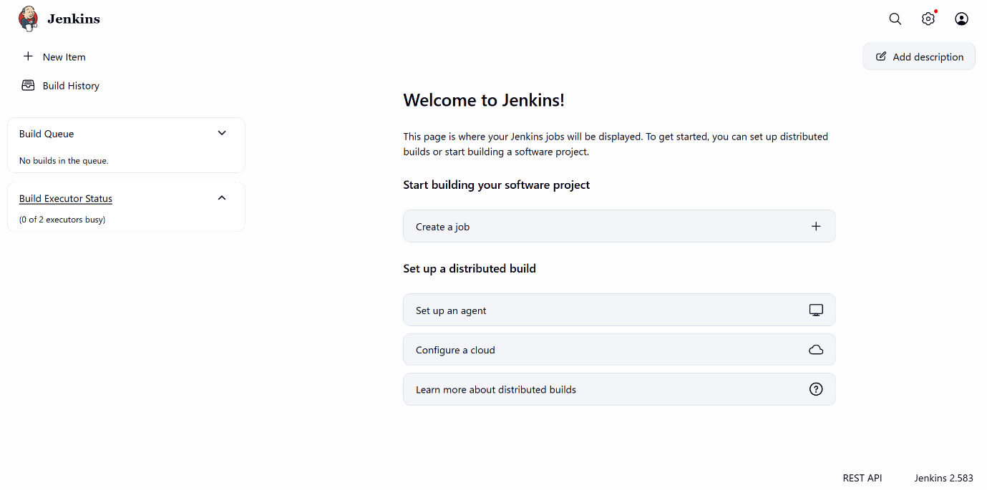
What this shows: Each product verified and the JavaScript fallback warnings.
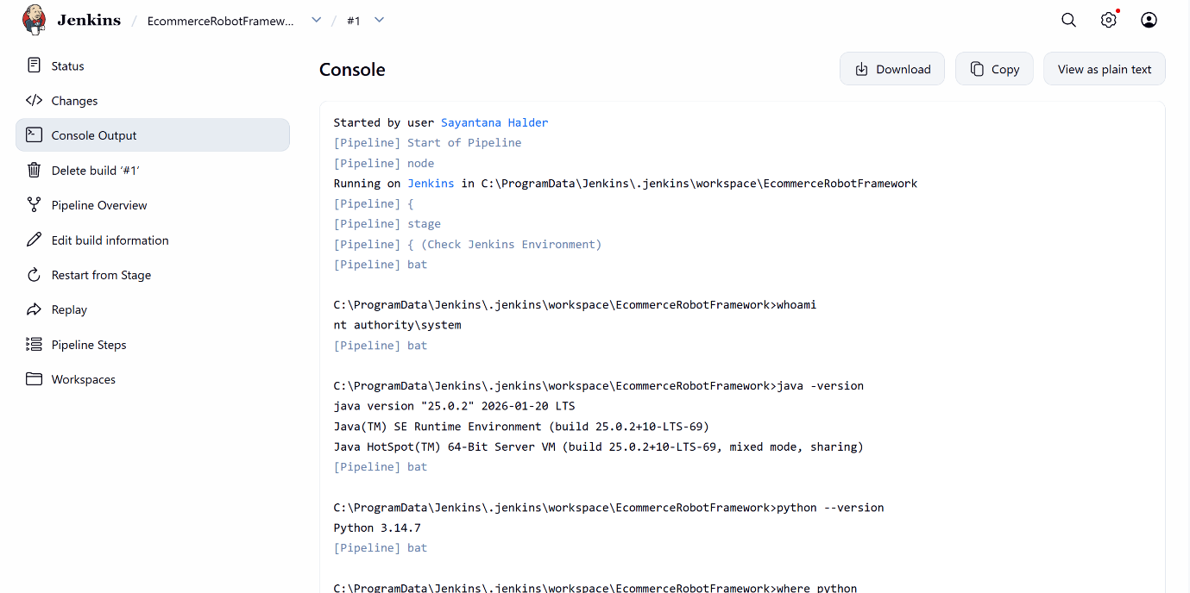
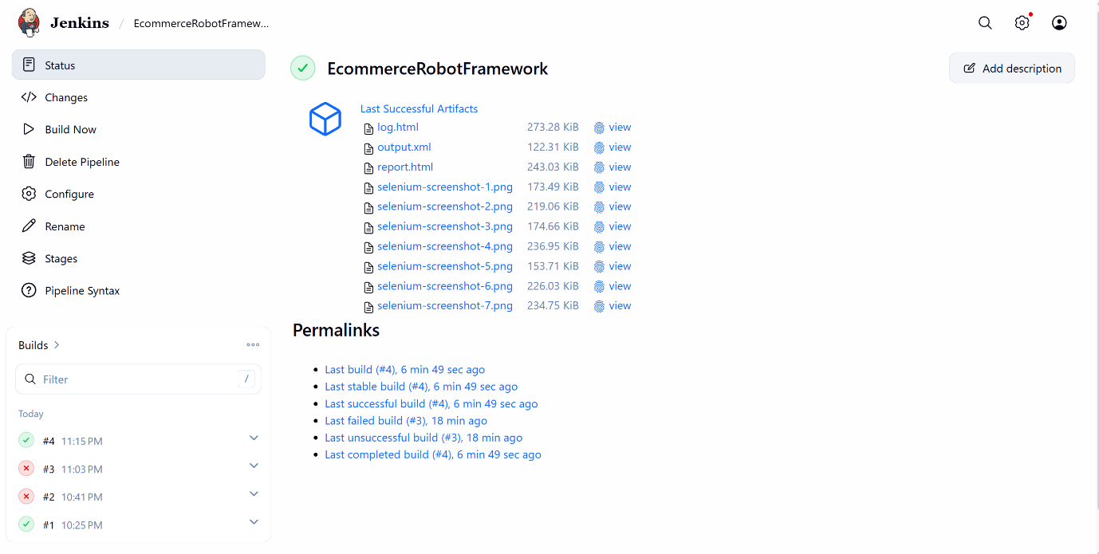

What this shows: The final status SUCCESS and the duration.

7. Results, Observations and Conclusion

7.1 Results
Table 4: Results of the three execution methods
Method | Scope | Result | Time
Command line | Dress, Top and Saree journey | 1 passed, 0 failed
RIDE IDE | Same journey | 1 passed, 0 failed | About 2 min 3 s
Jenkins | Same journey | 1 passed, 0 failed | About 4 min 56 s

The times were different. Browser start-up, network speed, advertisements, page loading and the different environments (Jenkins also creates a virtual environment and installs packages) could be reasons, but I did not test what actually caused the difference.

7.2 Observations
- Command line: fast and easy to repeat while debugging; the console printed the search term, the expected product and the cart contents for each product.
- RIDE IDE: the same test ran without any change to the code. RIDE showed the suite structure and the progress graphically, but it needed a separate installation and is used interactively.
- Jenkins: it needed the most set-up (service account, plugins, workspace, credentials), but it saves the reports with every build and can run the test from a job. The View Cart advertisement problem showed why the JavaScript fallback was needed.

7.3 Lessons Learned
- Page objects made the fix easy: only one keyword had to be changed.
- Real websites have advertisements, so a normal click with a JavaScript fallback makes the test stable.
- Names should be normalised before comparing, and the cart must be emptied before each product.
- Checking the Jenkins environment first separates setup problems from test problems.
- The Jenkins workspace is a separate copy of the project, and changes must be copied to it.
- The Jenkins console hides the secret values, but Robot’s log.html can still contain typed text such as the password (the login keyword uses Input Text), so the archived reports should not be shared publicly.

7.4 Limitations and Future Improvements
Limitations: the flow stops at the cart (no checkout or payment); the three CSV rows give only one test result; the test depends on a live website whose products and advertisements can change; the project was copied manually into Jenkins and builds were started manually; only Chrome was verified; and the CSV reader is simple (it splits on commas).
Possible future improvements (not implemented): show one result per CSV row using a test template or a data-driver library; use Git with checkout scm and automatic triggers in Jenkins; install the Robot Framework Jenkins plugin; pin package versions in requirements.txt; use Input Password for the password; add headless and multi-browser runs.

7.5 Conclusion
In this project I built a data-driven Robot Framework and SeleniumLibrary framework for an e-commerce shopping journey. It uses page objects, shared resource files and a CSV data file. One test case, in one login session, verified the correct products in the cart for Dress (Sleeveless Dress), Top (Blue Top) and Saree (Cotton Silk Hand Block Print Saree). The same test passed from the command line, from RIDE IDE and from a Jenkins pipeline, each with 1 test passed and 0 failed, and the reports (output.xml, log.html, report.html) were generated every time. The main problem was Google advertisements blocking clicks, which I solved with a JavaScript fallback click. The project does not cover checkout or payment, but it shows a maintainable structure and repeatable execution and reporting in three environments.

